 | ST KITTS & NEVIS  INTERNATIONAL SHIP REGISTRY |  |  |  | 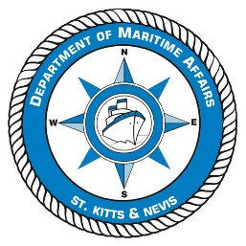
The Saint Christopher & Nevis Merchant Shipping Act, Cap. 7.05
Department of Maritime Affairs
APPLICATION FOR A CHANGE IN VESSEL NAME, OWNERSHIP OR OTHER DETAILS
PLEASE COMPLETE IN CAPITAL LETTERS IN BLACK INK OR BY TYPING.
NOTE THE DOCUMENTATION CHECKLIST RP10, RP11 & RP12 (where applicable)
VESSEL DETAILS
Name of Vessel |  |  | Port of Registry | IMO Number
Official Number |  |  | Call Sign | MMSI Number
DETAILS OF OWNER(s)
(continue on a separate sheet A10 if required)
Full Name of Owner(s) :
IMO Owner Number :
Name of Applicant :
(if different from owner)
DETAILS OF CHANGES THAT HAVE OCCURRED
(continue on separate sheet if required)

Signature of Applicant |  |  | Print Name
Date of Application |  |  | Title
Authority under which this document is signed (if applicable) i.e. Officer (Director) of company or Owner’s Agent etc

The person signing this application confirms that he/she is either the Owner or in the case of a Company, a duly authorised officer of that company or is the Owner’s agent. In the case of an Owner’s agent, such authority is to be supported by a written testimony giving such authority. By signing, he/she declares that to the best of his/her knowledge the information contained herein is correct.

