 | ST KITTS & NEVIS  INTERNATIONAL SHIP REGISTRY | 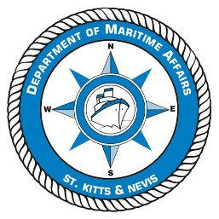
The Saint Christopher & Nevis Merchant Shipping Act, Cap. 7.05
Department of Maritime Affairs
CONTINUATION SHEET FOR DETAILS OF OWNERS/BAREBOAT CHARTERER(s)

If more than two owners, this continuation sheet is to be completed with details of the other owners as necessary and attached to the appropriate Application Form.

Full Name of Owner(s) or Bareboat Charterer(s): |  |  |  | Tel :
Address: | Address Line 1 : |  |  | Fax :
Address Line 2 : |  |  |  | Email :
Town/City : |  |  | Passport Number  (for individuals)
Post / Zip Code : |  |  | Number of Shares Held  (max no. of shares per ship is sixty four)
Country : |  |  | IMO Owner Number  (if known)
Full Name of Owner(s) or Bareboat Charterer(s): |  |  |  | Tel :
Address: | Address Line 1 : |  |  | Fax :
Address Line 2 : |  |  |  | Email :
Town/City : |  |  | Passport Number  (for individuals)
Post / Zip Code : |  |  | Number of Shares Held  (max no. of shares per ship is sixty four)
Country : |  |  | IMO Owner Number  (if known)
Full Name of Owner(s) or Bareboat Charterer(s): |  |  |  | Tel :
Address: | Address Line 1 : |  |  | Fax :
Address Line 2 : |  |  |  | Email :
Town/City : |  |  | Passport Number  (for individuals)
Post / Zip Code : |  |  | Number of Shares Held  (max no. of shares per ship is sixty four)
Country : |  |  | IMO Owner Number  (if known)
Full Name of Owner(s) or Bareboat Charterer(s): |  |  |  | Tel :
Address: | Address Line 1 : |  |  | Fax :
Address Line 2 : |  |  |  | Email :
Town/City : |  |  | Passport Number  (for individuals)
Post / Zip Code : |  |  | Number of Shares Held  (max no. of shares per ship is sixty four)
Country : |  |  | IMO Owner Number  (if known)

Signature of Applicant |  |  | Print Name
Date of Continuation |  |  | Title

