 | ST KITTS & NEVIS  INTERNATIONAL SHIP REGISTRY | 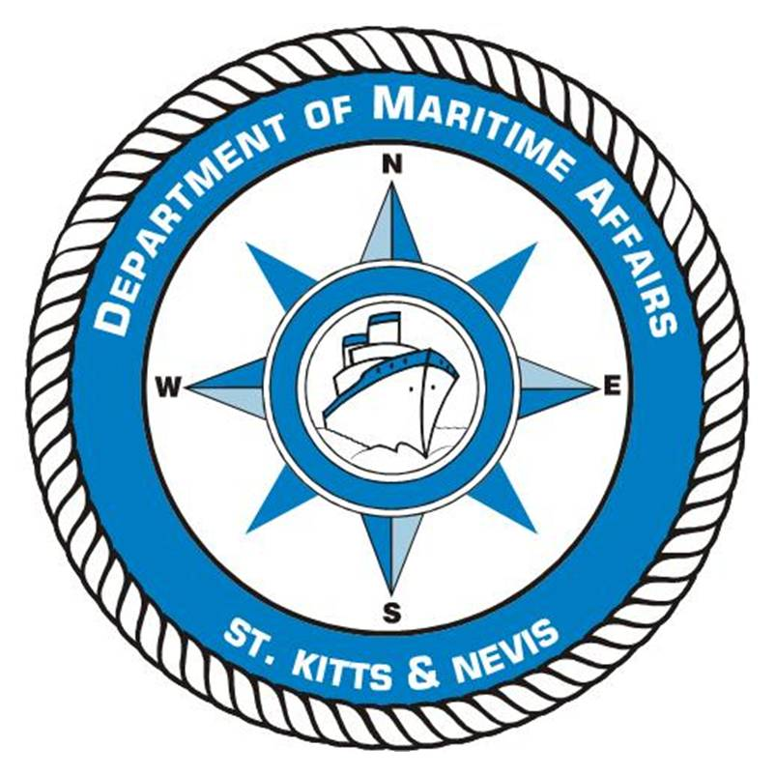
The Saint Christopher & Nevis Merchant Shipping Act, Cap. 7.05
And Telecommunications Act No.2 of 2000
Department of Maritime Affairs
APPLICATION FOR SHIP RADIO STATION LICENCE

PLEASE COMPLETE IN CAPITAL LETTERS IN BLACK INK OR BY TYPING.
NOTE THE DOCUMENTATION CHECKLIST RP4
VESSEL DETAILS
Name of Vessel | Gross Tonnage | Net Tonnage | IMO / Caribship Number
Type of Vessel | Official Number (N.A if new registration) |  | GMDSS Operating Area
Owners have entered into a contract with the following Radio Traffic Accounting Authority (Accounting Authority Identification Code – AAIC) and Point of Service (PSA) for the services described hereafter. A copy of the aforesaid contract(s) will be made available if so requested.
AAIC for Radio Communications |  | AAIC / PSA for Inmarsat Services

DETAILS OF OWNER(s)*
*for more than two owners, a continuation sheet is to be completed with details of the other owners as below. Please tick here ( ) if continuation sheet is added
Full Name of First (or only) Owner : |  |  |  | Tel :
Address: | Address Line 1 : |  |  | Fax :
Address Line 2 : |  |  |  | Email :
Town/City : |  |  | IMO Owner Number  (if known)
Post / Zip Code : |  |  | Passport Number  (for individuals)
Country :

Signature of Applicant |  |  | Print Name
Date of Application |  |  | Title
Authority under which this document is signed (if applicable) i.e. Officer (Director) of company or Owner’s Agent etc

The person signing this application confirms that he/she is either the Owner or in the case of a Company, a duly authorised officer of that company or is the Owner’s agent. In the case of an Owner’s agent, such authority is to be supported by a written testimony giving such authority. By signing, he/she declares that to the best of his/her knowledge the information contained herein is correct. In the case of an application for renewal the owners hereby confirm in making this application that there are no changes of the ship radio station equipment and electronic navigational equipment since the Ship Radio Station Licence has been issued. If there are changes, please give details of the new equipment installed on a separate sheet with a copy of the Installation Report from the technician/surveyor.

PLEASE COMPLETE THE RECORD OF INSTALLED EQUIPMENT TABLE ON PAGE TWO (2) IN THE CASE OF AN APPLICATION FOR A FIRST LICENCE OR WHEN THE EQUIPMENT ONBOARD HAS CHANGED.

RECORD OF INSTALLED EQUIPMENT

RECORD OF INSTALLED EQUIPMENT
Equipment | Manufacturer | Type No. | Power | Emission | Frequency Band
VHF Radiotelephony
VHF/DSC Encoder / Decoder
MF Radiotelephony
MF/DSC Encoder / Decoder
MF/HF Radiotelephony
MF/HF/DSC Encoder / Decoder
Inmarsat SES
Navtex Receiver
EGC Receiver
Satellite EPIRB
VHF EPIRB
Radar Transponder (SART)
Radio Direction Finder
Main Transmitter
Main Receiver
Reserve Transmitter
Reserve Transceiver
VHF Transceiver
Two-way Radiotelephone VHF
Radar 1
Radar 2
Auto alarm Apparatus
Automatic Keying Device
Lifeboat VHF
Other Equipment

Signature of Master /  Approved Radio Surveyor |  |  | Print Name
Date of Application |  |  | PLEASE AFFIX APPLICANTS STAMP/SEAL

