 | ST KITTS & NEVIS  INTERNATIONAL SHIP REGISTRY | 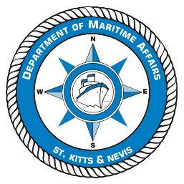
The Saint Christopher & Nevis Merchant Shipping Act, Cap. 7.05
Department of Maritime Affairs
APPLICATION FOR AN EXEMPTION CERTIFICATE OR LETTER OF DISPENSATION
To be completed by the Owner/Owner’s Agent when requesting an exemption or dispensation from any provisions of the Merchant Shipping Act or associated regulations or any IMO Convention to which St Kitts & Nevis is a party.

PLEASE COMPLETE IN CAPITAL LETTERS IN BLACK INK OR BY TYPING.
NOTE THE DOCUMENTATION CHECKLIST RP28
VESSEL DETAILS
Name of Vessel | Official Number | IMO Number
Vessel Type | Length (ITC 69) | Gross Tonnage (ITC 69)

DETAILS OF OWNER
Name of Owner :
IMO Owner Number (if known) :

We being the Owner/Owner’s Agent *(delete as applicable) of the above mentioned vessel do hereby apply to St Kitts & Nevis International Ship Registry for an Exemption Certificate / Letter of Dispensation *(delete as applicable) according to Sections 187 and 445 of the Merchant Shipping Act No. 24 of 2002, for the reasons as more fully described below.

1) | Equipment and/or regulation for which the Exemption / Dispensation is requested:

2) | Reasons for requesting the Exemption / Dispensation:

3) | Regulation that grants the right to an Exemption / Dispensation:

4) | Voyage to be undertaken in respect of this Exemption Certificate
  Port & Country of Departure | Port & Country of Arrival | Voyage Duration (in days)

5) | Validity of the Statutory or other Certificate to which the Application for Exemption refers:  (Copy of Certificate to be attached to this request)

6) | Validity of the Statutory or other Certificate to which the Application for Exemption refers:  (Copy of Certificate to be attached to this request)

7) | Special conditions or further remarks:

Signature of Applicant |  |  | Print Name
Date of Application |  |  | Job Title
Authority under which this document is signed (if applicable) i.e. Officer (Director) of company or Owner’s Agent etc

