 | ST KITTS & NEVIS  INTERNATIONAL SHIP REGISTRY |  |  |  |  | 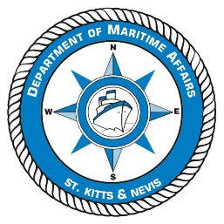
 | The Saint Christopher & Nevis Merchant Shipping Act, Cap. 7.05
Application for issue or change of a Declaration of Maritime Labour Compliance Part 1
PLEASE COMPLETE IN CAPITAL LETTERS IN BLACK INK OR BY TYPING.
NOTE THE DOCUMENTATION CHECKLIST RP33
VESSEL DETAILS
Name of Vessel |  |  |  | Ship Type
IMO / CaribShip Number |  |  | Official Number | Date Keel Laid | Gross Tonnage
 |  |  | SKN 100
DETAILS OF SHIPOWNER(s) { MLC 2006 Article II (j) } *
(continue on separate sheet A10 if required)
Full Name :
Address :
Recognised Organisation assigned for MLC Survey
Consideration of SUBSTANTIAL EQUIVALENCIES under Article VI para 3 &4 of the Convention as listed below, is requested
(continue on separate sheet if required)
The following EXEMPTIONS as provided under Title 3 of the Convention have been requested
(continue on separate sheet if required)

Note that time spent considering allowing SUBSTANTIAL EQUIVALENCIES or EXEMPTIONS will be chargeable.

Signature of Shipowner or Representative |  |  | Print Name
Date of Application |  |  | Title
Authority under which this document is signed (if applicable) i.e. Officer (Director) of company or Owner’s Agent etc

“Shipowner” means the owner of the ship or another organisation or person, such as the manager, agent or bareboat charterer, who has assumed responsibility for the operation of the ship from the owner and who, on assuming such responsibility, has agreed to take over the duties and responsibilities imposed on the shipowners in accordance with the Convention, regardless of whether any other organisations or persons fulfil certain of the duties or responsibilities on behalf of the shipowner.

Documents to be submitted with this Application - P&I Club Certificate of Entry, or other evidence of financial security for shipowners obligations to seafarers – Standards A2.5, A2.6 & A4.2 of MLC 2006

